
CSA05-DATABASE MANAGEMENT SYSTEMS

AIM
To create view and index on the given relation.

DESCRIPTION
A view is a virtual table based on the result of a SQL query. An index is a database object used to improve the speed of data retrieval from a table.

TABLE USED
CoffeeShop

1. Select Database
USE collegedb;

2. Remove Existing View
DROP VIEW IF EXISTS v1;
OUTPUT:
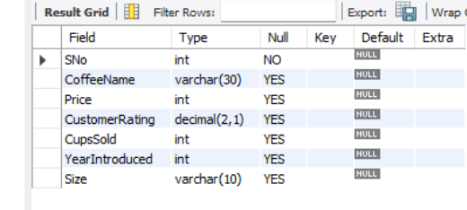

____________________________________________________________

3. Create View v1
CREATE VIEW v1 AS
SELECT SNo, CoffeeName, Price, CustomerRating, CupsSold, YearIntroduced, Size
FROM CoffeeShop;
OUTPUT:



4. Display the View
SELECT * FROM v1;
OUTPUT:
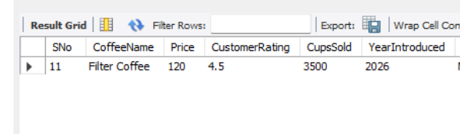

5. Display View Structure
DESC v1;
OUTPUT:
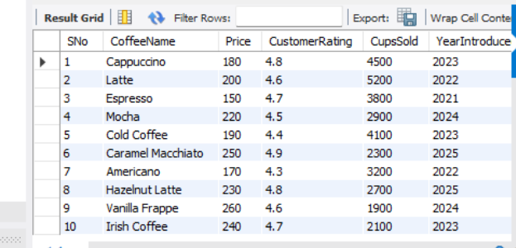

6. Insert a Record Through the View
INSERT INTO v1
(SNo, CoffeeName, Price, CustomerRating, CupsSold, YearIntroduced, Size)
VALUES (11, 'Filter Coffee', 120, 4.5, 3500, 2026, 'Medium');
OUTPUT:
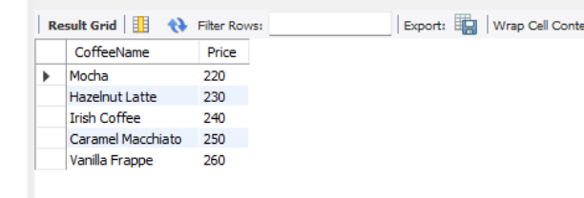

7. Verify the Inserted Record
SELECT * FROM v1 WHERE SNo = 11;
OUTPUT:
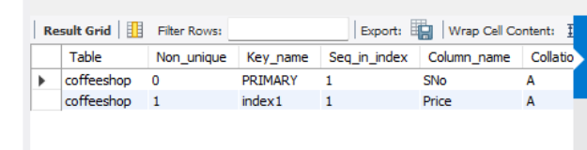

8. Delete the Record Through the View
DELETE FROM v1 WHERE SNo = 11;
____________________________________________________________

9. Verify the Deletion
SELECT * FROM v1;
OUTPUT:
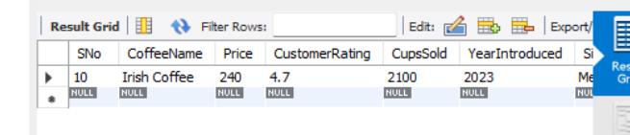

10. Create Index on Price
CREATE INDEX index1 ON CoffeeShop (Price);
OUTPUT:


11. List Coffees with Price Above ₹200
SELECT CoffeeName, Price
FROM CoffeeShop
WHERE Price > 200;
OUTPUT:
Screenshot:

____________________________________________________________

12. Display Index
SHOW INDEX FROM CoffeeShop;
OUTPUT:



13. Drop Price Index
DROP INDEX index1 ON CoffeeShop;

14. Create Index on SNo
CREATE INDEX index1 ON CoffeeShop (SNo);

15. Display Record with SNo 10
SELECT * FROM CoffeeShop WHERE SNo = 10;
OUTPUT:



16. Display Index on SNo
SHOW INDEX FROM CoffeeShop;

17. Drop SNo Index
DROP INDEX index1 ON CoffeeShop;
OUTPUT:
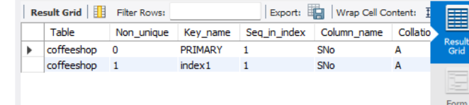

INDEXING PRINCIPLE
Indexing is a technique used to improve the speed of data retrieval from a database table. An index helps the database locate required records efficiently without scanning the entire table.

RESULT
Thus, a view was created and operations were performed on the view. Indexes were created on Price and SNo, used for data retrieval, displayed and dropped successfully.

